Introduction to Amazon Glacier

The amount of data that you need to store and manage is growing and costing you more money every day

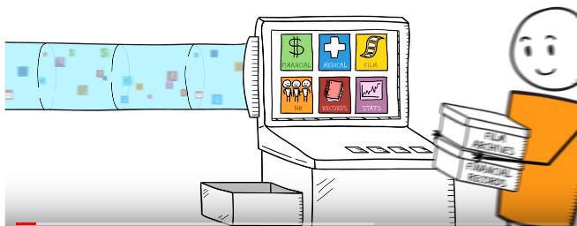

A lot of your data isn't access very often but you still need to store it securely for future reference and compliance.

Moving this cold data to a long-term storage repository can help save storage costs but finding a simple and secure way to archive it isn't easy.

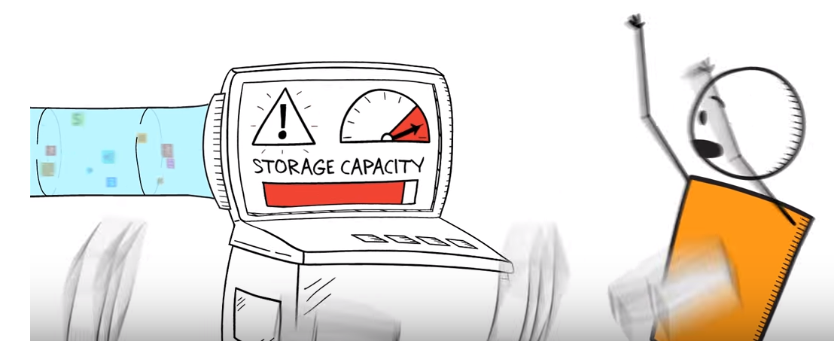

First you have to purchase a.) lots of expensive hardware ..including b.)racks of servers and tape drives and then pay the c.)ongoing operational costs for power facilities staffing and maintenance.

Next you have to guess how much capacity you need in the future…

Getting this wrong means either

* not having the storage, you need or
* you overspend and end up with excess capacity that sits idle …and

then you have to continually make sure your data stays healthy through laborious data verification and manual repairs …



Amazon glacier is an extremely low-cost secure and durable storage service for data archiving and backup.

It's designed to keep costs low and is optimized for cold data where retrieval times of 3 to 5 hours are suitable with glacier.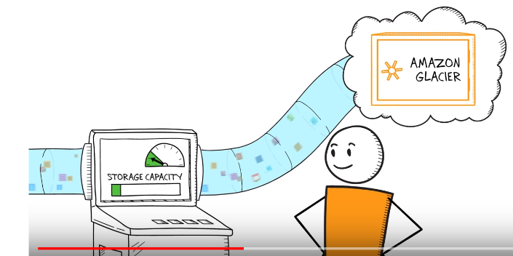

You can reliably store large or small amounts of data for as little as a penny per gigabyte per month and there's no limit on how much data you can store… and you only pay for what you use..

So you don't have to try to predict the future and pay for storage.

You don't want to have to worry about is losing your data… Amazon glacier helps protect your data by redundantly storing it on multiple devices across multiple facilities. 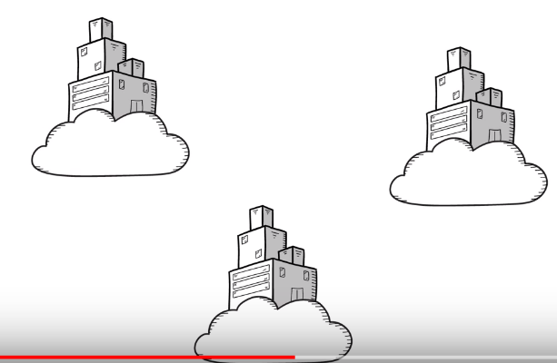

Glacier helps maintain your data with regular systematic data integrity checks… 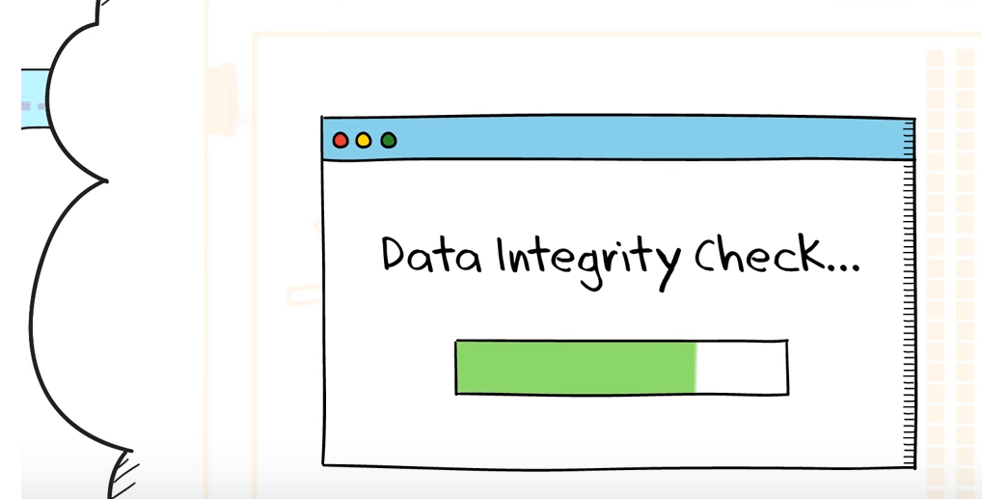 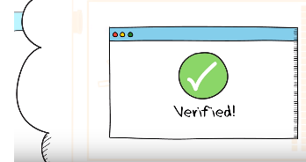

Keeping your data safe against unintended access is really important.

Amazon glacier lets you manage fine-grained access to your data with AWS Identity and Access Management policies.

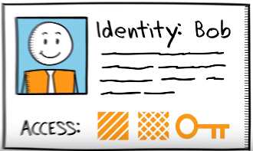

It secures your data in transit with SSL and automatically encrypts your data at rest with 256 bit advanced encryption standard.

In addition you can choose the AWS region to store your data based on the location that best meets your regulatory and business criteria .

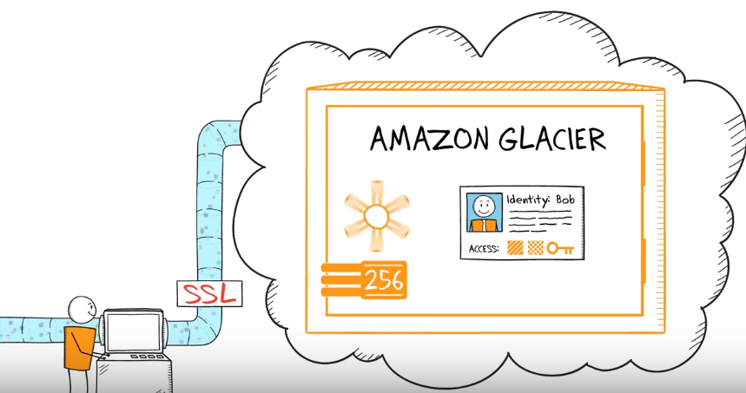

There are a number of simple ways to move your data into Amazon glacier.

🡪you can use the AWS SDK to upload data directly to the service

🡪 if you use Amazon s3 you can use s3 lifecycle policies to automatically archive cold data to Amazon glacier. 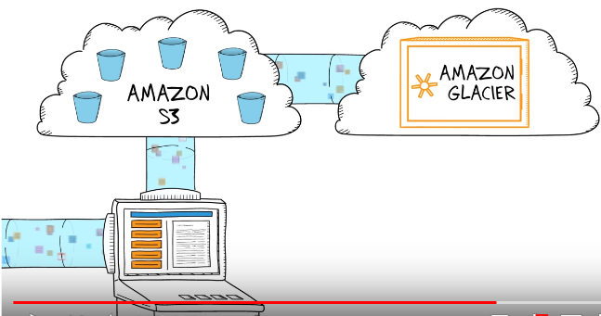

🡪f you already have a repository of cold data you can use the AWS import/export service to transport it into Amazon glacier with portable storage devices. 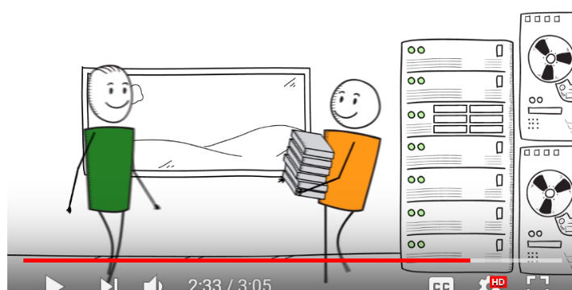

🡪 you can also use third-party gateways and tools to move your data to glacier Amazon glacier makes it easy for you to store all your cold data for a very low price.

You pay nothing upfront and can scale your usage up or down as needed…

# Archiving Amazon S3 Data to Amazon Glacier

# How to achieve S3 objects to Glacier and restore back...

# you have to first upload your objects to either standard storage or reduced redundancy storage RRS and then ask s3 to archive them using life cycle rules.

# In this video, we will set up a life cycle rule on the bucket s3.

# s3 🡪 locate the bucket whose contents you wish to transition to glacier. In this case, S3_archieve..

# If you want to archive files that are not in Amazon s3, then upload them to your bucket…

# 

# After uploading the files click on the bucket and then click on the properties button now navigate to the lifecycle tab in the properties pane… here you can create lifecycle rules that define conditions for moving objects to glacier.

# Click add rule the lifecycle rule dialog appears, we will setup this rule to our log files that are 30 days old.

# glacier and remove them when they are 365 days old.

# a.)give the rule a name such as logs_archive and then

# b.) enter the object prefix logs forward slash in the object prefix field this rule is now applicable for all objects whose name starts with log slash in the bucket s3_archive.

# c.)next select one of the two options in the time period format field.

# You can choose to schedule the transition based either on a specific date or by selecting days from the creation date to schedule a transition to glacier.

# click the add transition button and specify the number of days from the creation date after which objects should transition (30 days)

# d.) if you also want to have your objects deleted based on the schedule then click the add expiration button and fill in the time period box.

# 

# for this rule we specify 30 days for transition and 3,600 50 days for the expiration action.

# 

# This rule will now move all objects matching the prefix in our bucket that are 30 days old to glacier and delete all objects matching the prefix that are 3650 days old.

# 

# Archived objects are Amazon s3 objects and they are accessible only through the Amazon s3 console or via api's …

# You can identify them as having the storage class glacier by viewing the objects details pane.

# 

# restoring objects archived to amazon glacier

# archived objects are not available for you to download.

# You must first restore them.

# 

# The restore process takes three to five hours and creates a temporary copy in RRS.

# restore

# navigate to your bucket… right-click on the object and select restore from the context menu.

# You must specify a time period setting for the restore request.

# The time-period is the duration for which the temporary copy of your data will remain available in s3.

# enter 5 days and click OK .

# 🡪To check the status of your restore.., click on the object and select properties.

# 

# you'll see the restore status on the details pane…

# Restoring an object typically takes between three to five hours to complete..

# Once the restore is complete you can then download the object this object will remain available for the next five days… since we specified that restore period.

# You can change the restore period to make the object available for a longer or shorter duration by restoring the object again with an updated time period or by clicking the modify button.

# 

# AWS Knowledge Center Videos: How do I restore Glacier objects with restore tiers in the S3 Console?

# how they can restore Amazon glacier objects with restore tiers in the Amazon s3 console.

# Many customers store files in their s3 buckets and archive them to Amazon glacier over time so they can reduce cost.

# At some point they need to restore archived files from Amazon glacier back to Amazon s3, so they can access them in real time.

# today I want to show you how you can restore objects archived in Amazon glacier from within the Amazon s3 console and how you can choose a restore tier that best meets your needs …

# Prerequisite:

# 

# You can see a set of objects that I've already uploaded in my bucket… Here I can sort them by storage class and you can see that I have several objects in standard, standard IA and a number of objects in Glacier storage class.

# let's find a glacier object that I want to restore..

# when I click on that you can see the attributes of this object ….here's the key name here's the size it's about 25 megabytes..

# 

# 

# when you restore an object from glacier to S3.S3 is going to create a temporary object for you and place that in the same bucket at this point.

# You can specify how many days you want this temporary object to be available for

# I'm going to choose 1 day and then

# with the restore you have three options..

# you have the bulk retrieval option which makes your data available in 5 to 12 hours

# with the expedited retrieval option your data will come back in 1 to 5 minutes

# with the standard retrieval your data will come back in 3 to 5 hours

# I

# Getting Started with Amazon Glacier

Amazon glacier is a low-cost storage service that provides secure and durable storage for data archiving and backup. Glacier is designed with the same durability and reliability as Amazon simple storage service or s3..

However glacier is optimized for storing data that isn't frequently accessed and for which retrieval times of several hours are suitable… In doing so glacier is able to reduce costs significantly which is very important for data archives and back up.

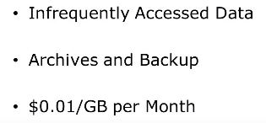

With glacier customers can reliably store large or small amounts of data for as little as one cent per gigabyte per month.

Data is stored in glaciers as archives.

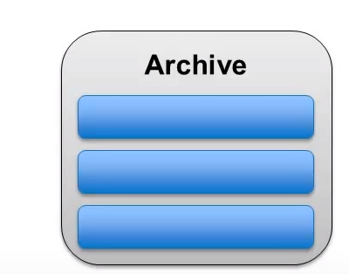

An archive can represent a single file or you may choose to combine several files to be uploaded as a single archived..

Archives are similar to objects in s3 but will often be a collection of objects bundled together similar to a zipper tar file.

Archives in Glacier are organized into vaults.. 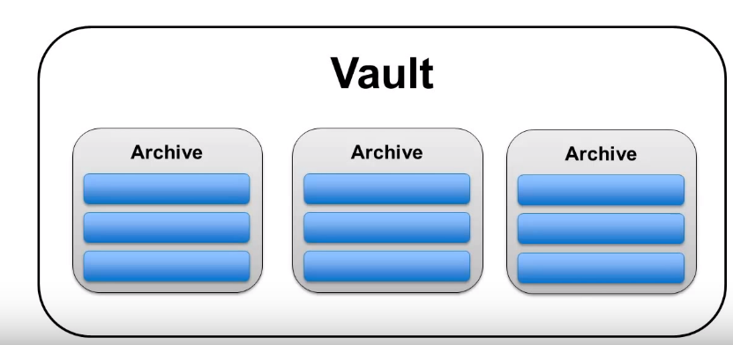

* Vaults are collections of archives that allow you to set access and notification policies.
* Vaults also allow you to keep track of the archives that you upload to Glacier once-a-day.
* Each vault has an inventory generated for it which lists the archives contain within and information such as the total size of all the archives and the number of archives in the vault.

**DEMO:**

Select glacier 🡪select the region you would like to use…

click create vault.

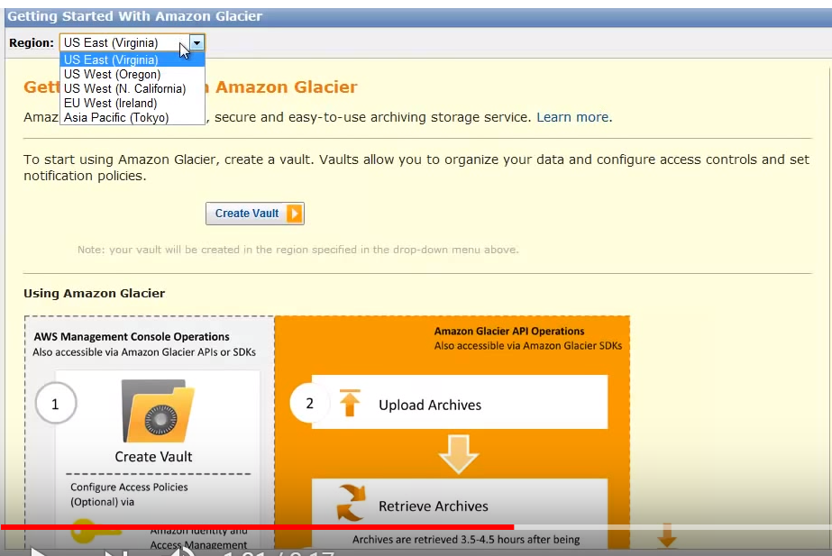

go ahead and give your Vault name.

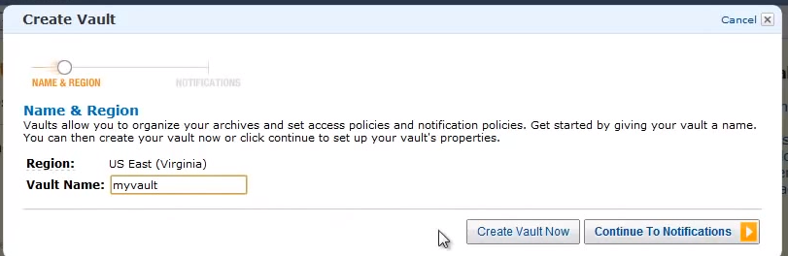

click continue to notifications…

Notifications are sent through Amazon simple notification service (SNS)..

You can create a new SNS topic or you can use an existing SNS topic.

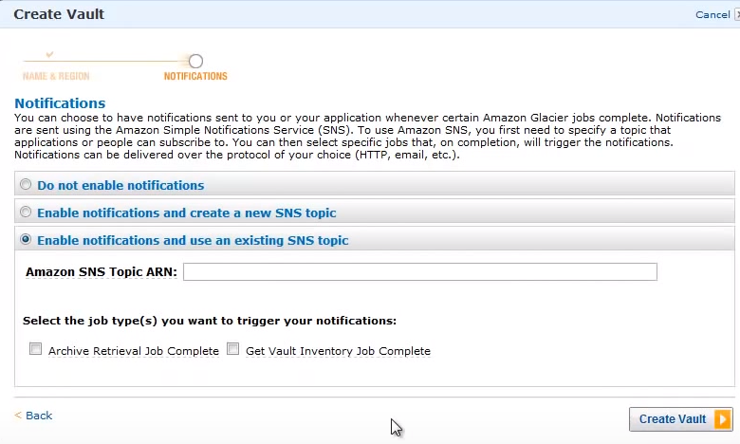

You can also choose to disable notifications… These notification settings can be changed at any time through the management console… click create vault.

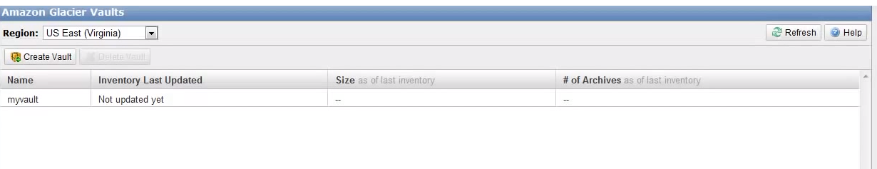your vault has been created..

The console now shows a list of all your existing vaults …we only have one vault which we just created.

Select your vault and in the lower panel ,you can see the details of your vault such as the ARN and the inventory summary..

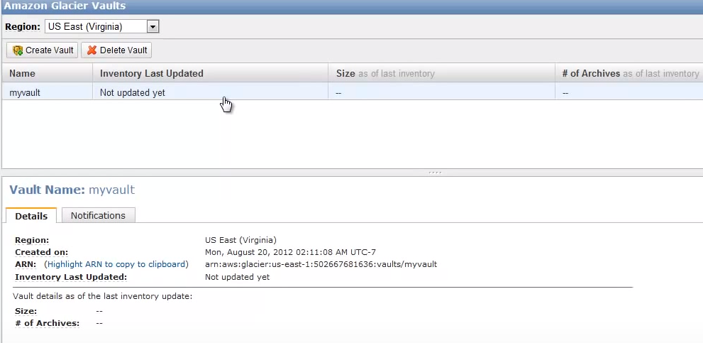

this inventory contains the list of all the archives within a vault.

You will be able to see the size and number of archives contained in your vault at the time of the last inventory.

As vault inventories only run once a day you may have to wait up to 24 hours or so for your vault inventory to be updated.. because we just created this vault the inventory summary is currently empty.

Retrieving data from glacier requires the initiation of a retrieval job .These retrieval jobs complete in approximately 4 hours. Any notification policies that you have created will allow you or your application to be notified when a retrieval completes and your data is ready for download. 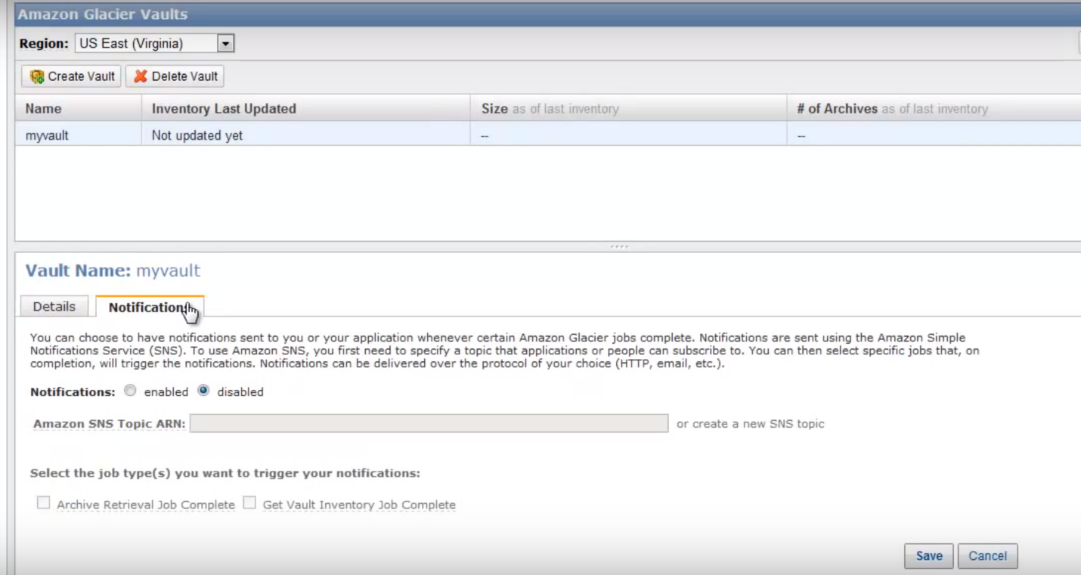

Your notification policies can be edited at any time via the console by clicking on the notifications tab congratulations your Amazon glacier valve has been set up and you can now upload and retrieve data using the service SDKs and API.

# Amazon Glacier Tutorial | AWS Glacier Tutorial | AWS Tutorial | AWS Services | Simplilearn

# 

# Amazon glacier Amazon glacier is an economical storage solution to store data that would remain forever but rarely accessed.

# It is an ideal choice for data backup and archiving.

# Provides data security of the highest level and

# Offers flexibility in both storing and retrieving data.

# AWS builds you for only the used data or storage and current lease price for storing data in Amazon glacier is 0:07 cents per gigabyte per month.

# Glacier Features

# Maintaining historical data can be a grief as it is added to the administrative liability of managing the scaling storage.

# Amazon glacier eases this hardship by providing features such as:

# Capacity planning

# hardware provisioning

# detecting and repairing hardware failure

# data replication and

# hardware migrations.

# Glacier-Data Storage:

# 

# When you preserve data in Amazon glacier it is stored as archives.

# This enables a user to store a single file or a combination of several files.

# Archives are arranged in vaults which can be accessed using the AWS IAM service.

# Amazon glacier stores data in transit via SSL and uses the 256 bit advanced encryption system.

# Types of Data

# AWS enables organizations to store data in a location that is convenient for their businesses and Organizations tend to utilize Amazon glacier to support the following use cases:

# 

# Archiving off-site enterprise information.

# Backing up media assets.

# storing research and scientific data.

# preserving digital data and

# replacing magnetic tapes.

# Durability and Availability:

# Amazon glacier archives offers an average annual resilience of 99.999999 999%. (9…. 9’s)

# 

# The archiving service maintains resilience by continuously utilizing several facilities and devices

# within each facility to store the data the task continues till the service returns success on the uploading archives.

# Archieves

# Any individual object archived in to Amazon glacier such as a document video or any other type of file is referred to as an archive.

# 

# Each archive has a unique ID assigned to it by AWS.

# 

# The archives are stored in vaults a vault is addressed by a unique name assigned to it by its creator.

# A given AWS account may create up to 1000 vaults in Amazon glacier.

# you can refer to an archive in Amazon glacier via a URL that points to the glacier service and consists of the following three components:

# 

# the account ID of your AWS master account.

# the name of the vault

# the ID of the individual archive

# Stored Data

# 

# Data stored in Amazon glacier by Amazon s3 cannot be retrieved using the Amazon glacier API.

# This is the data that Amazon s3 manages on your behalf and it does not show up as a vault or archive Amazon s3 archived files can be restored using the s3 management console interface or using the Amazon s3 API.

# Files added directly to Amazon glacier using the Amazon glacier API can be retrieved using the glacier API.

# Retrieval requests can be any one of the following:

# direct retrieval of a single archived object by archived ID.

# Filter by archive creation date

# ranged archive retrieval-- retrieve only a specific range of bytes from a specific archive.

# You can pull for job completion using the described job API function.

# Amazon glacier completion notifications can also be sent using Amazon simple notification service or SNS.

# Once an Amazon glacier job has finished executing the user can request a download of their thawed data.

# *DEMO*

# In this demonstration you'll learn how to configure Amazon s3 buckets for archiving in Amazon glacier which is a lost cost storage service.

# 

# Go to s3 under the storage and content delivery section.

# Select your required bucket Ex: test 11 October bucket.

# click the lifecycle option...

# click Add rule

# 

# select the whole bucket option, and then click the configuration rule button

# select the archive to the glacier storage class option.

# state the number of days after the completion of which you want the data in your s3 bucket to move to the glacier…. for this demonstration we'll provide 30 days.

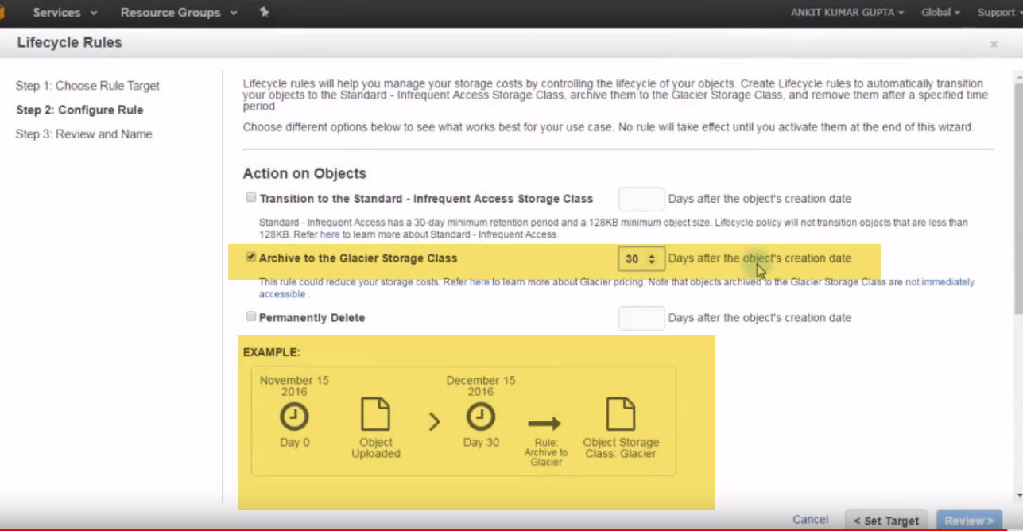

# ignore that you are aware that setting up this particular rule will likely increase your storage costs.

# 

# click review and provide a rule name ….you can review your rule on this page.

# 

# Create IAM user account, and generate access key for user\

# 

# This is like userId (access key and password (secret access key).

# Account Glacier created. But it didn’t have any permissions.

# Goto🡪Permissions-🡪 Attach policy..> Select Glacier full access

# 

# 4.)Goto Glacier-🡪

# Create a new storage area …Vault (In S3 called as Bucket)

# I have created Microvault now..

# We have ARN (address to reach this vault).

# 

# I have framework created…How do I backit up???.

# We need some software. .

# These are need to access API.

# Cloud Berry Explorer free. OR FAST GLACIER FREE

# 

# 

# Add account.

# Now, here is my accout

# 

# If we need automated, they have to paid product..